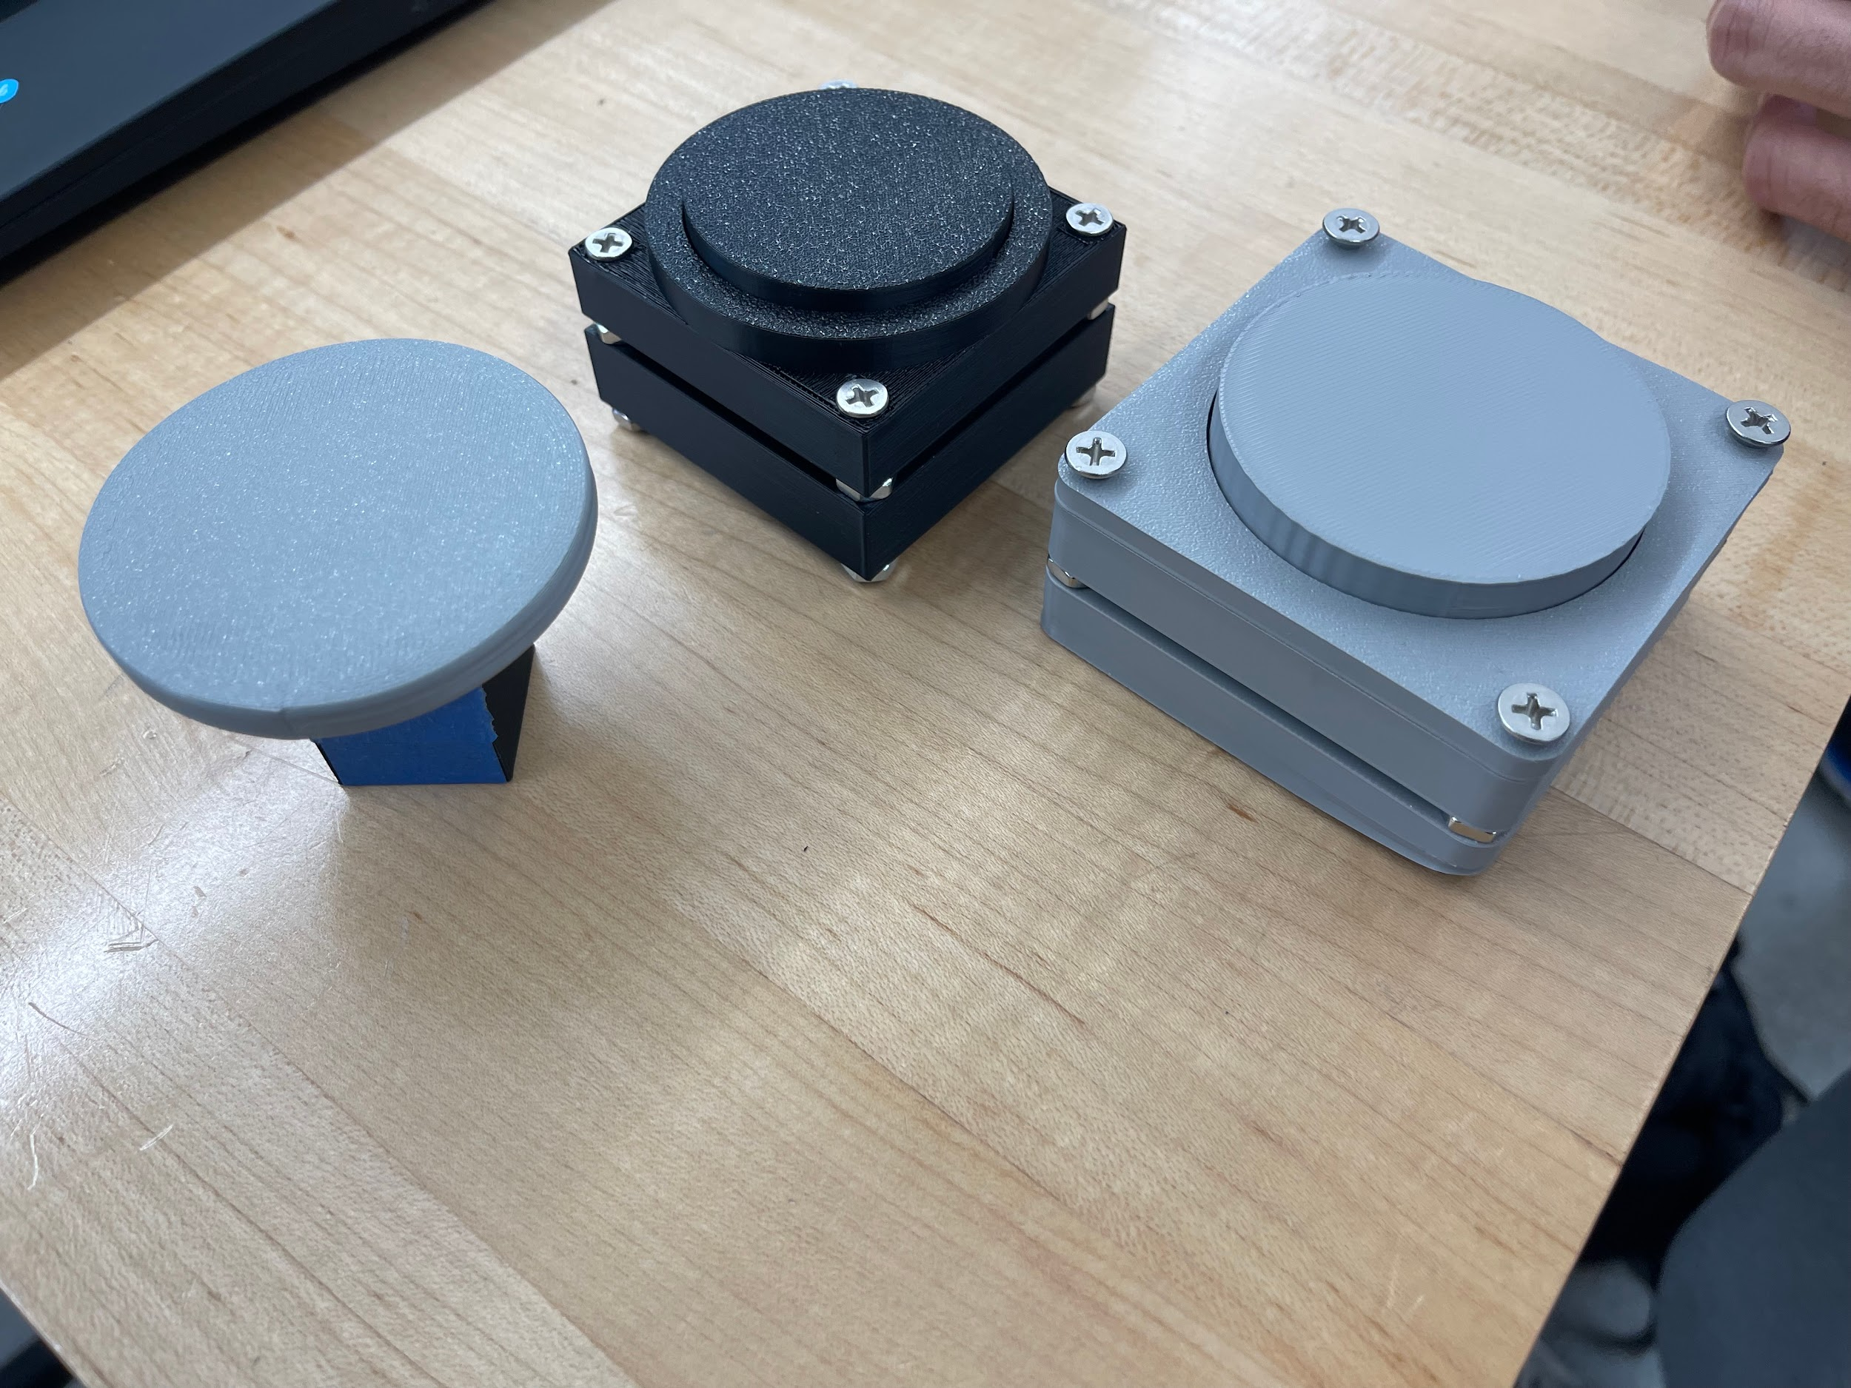

With this prototype, we made a set of different buttons to learn from Reach the sound and feel of the buttons that they would prefer. We learned that they preferred the noise of the black button and the feel of pressing the gray button on the left in the image above.

Tangibility: Physical, fully created objects

Completeness: Focused, aimed specifically for testing of buttons

Detail: More refined than rough, using nicer 3D printing material as well as screws and springs

Expenditures: N/A